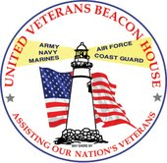
UNITED VETERANS BEACON HOUSE, INC.
1715 Union Blvd, Bay Shore, NY 11706 ~ PH 631-665-1571 ~ Fax 631-665-1578 ~www.UVBH.com

VetsBuild 2015 Class Schedules

- March 30th to May 7^{th*}
M-Th 1:30pm – 4:30pm

- May 11th to June 18^{th*}
Times to be announced

- Oct 5th to Nov 12^{th*}
Times to be announced

*Be advised that there are 2 days where OSHA training will be conducted from 9am to 4pm.
Those days are to be announced.

www.GoodSearch.com
Choose United Veterans Beacon House
Turn your shopping and searching into donations for a good cause!

Like us and share our page on Facebook:
www.Facebook.com/UnitedVeteransBeaconHouse

